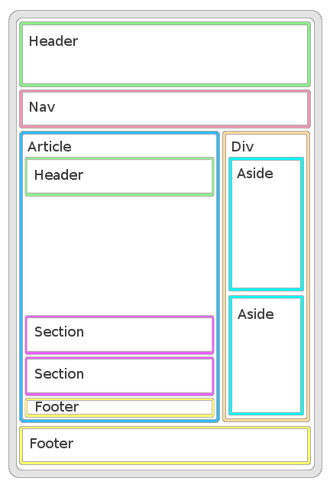

HTML offers several semantic elements that define the different parts of a web page:

|  |  |
| --- | --- |
| HTML5 Semantic Elements | * <header> - Defines a header for a document or a section * <nav> - Defines a container for navigation links * <section> - Defines a section in a document * <article> - Defines an independent self-contained article * <aside> - Defines content aside from the content (like a sidebar) * <footer> - Defines a footer for a document or a section * <details> - Defines additional details * <summary> - Defines a heading for the <details> element |

